Web Portal Design
Version: | 0.1
Author(s): | Aleksandar Tolev
Created: | 04/27/2009
Last modification:

Version | Date | Author(s) | Changes
0.1 | 04/26/2009 | Aleksandar Tolev
Contents
1. Introduction 2
2. Packages 2
3. Design Patterns 5
3.1. Builder Pattern 5
3.1.1. UIBuilder 5
3.1.2. Concrete Builder 6
3.1.3. Director 6
3.1.4. Communication 6
3.2. Observer Pattern 7
3.3. Action Registry 8
3.4. Singleton pattern 9
4. Data Binding 9
5. Navigation 9
6. Portal view structure 10
7. Authentication and start page 10
8. Session Management 11
9. Secure connections 12
10. Multiple windows 12
11. Different tenant view 13

Introduction
The following document describes the design of the web portal. In the “DecidR” application the web portal presents the user interface.
Some aspects of the design for example several design patterns, packages, data binding and navigation, session management, secured connections and the user interface’s structure will be described.

Packages

The whole web portal will be designed with the Model-View-Controller (MVC) pattern. To achieve the MVC pattern the web portal is divided into three packages.
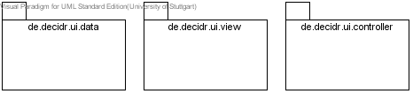

In the data package the data for the web portal is stored. All containers which hold items for representing the data in the web portal are stored in this package. Every container class extends the observable class. For more information have a look at Observer Pattern. The container classes implement the com.itmill.toolkit.data.Container interface, so that these classes can use specific methods from the ITMILL framework container. Also the different roles are implemented in the data package. The user objects are implemented through a facade which is given from the main model of the “DecdiR” application.
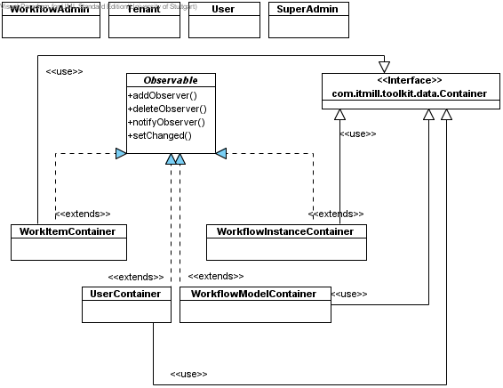

In the de.decidr.ui.controller package all action classes are stored. These action classes are used for managing the page flow and for handling actions. For more information have a look at Navigation. The actions are connected with the action registry, which is also stored in this package. For detailed information see Action Registry. The last important class in this package is the UI director class. This class manages the view constructing. In the section Director you can find more information. Over the controller package all actions are handled. If the user interacts with the application and wants to change data, the controller is notified and triggers events to perform the action.

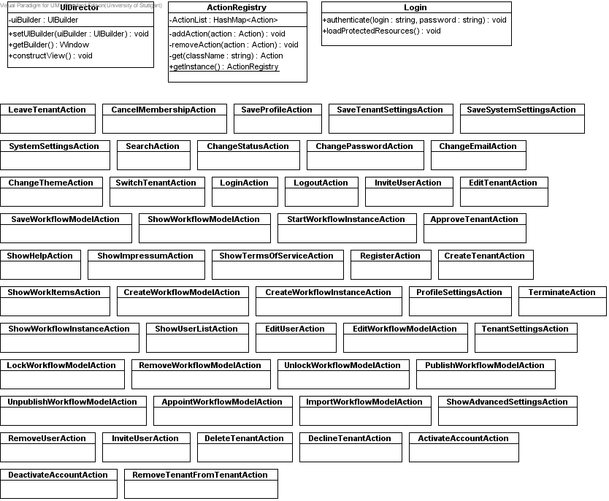
The third package is the com.decidr.ui.view package. Here all view components are stored. That means components like user menu, header, footer, impressum window, help window, super admin menu and so on is stored in this package. All these components have an init() method where the specific components like buttons, labels, text fields and so on are built. Also, all classes are implemented with the Singleton pattern, so that we can refer to one object onlay. The particular view components are used for building the concrete view in the four different UI builder: UserViewBuilder, TenantAdminViewBuilder, WorkflowAdminViewBuilder and SuperAdminViewBuilder. These four builder classes extend the UIBuilder class which represents an interface. For detailed description on how the UI builder and concrete builder work see Builder Pattern. The view components which represent a table or a list are stored in this package, too. They implement the observer interface for being up to date when the data has changed. Detailed information can be found in Observer Pattern. They have the init() method and are implemented with the Singleton pattern, too. The template view class builds a template where view components can be added or removed. It extends the com.itmill.toolkit.ui.Window class.
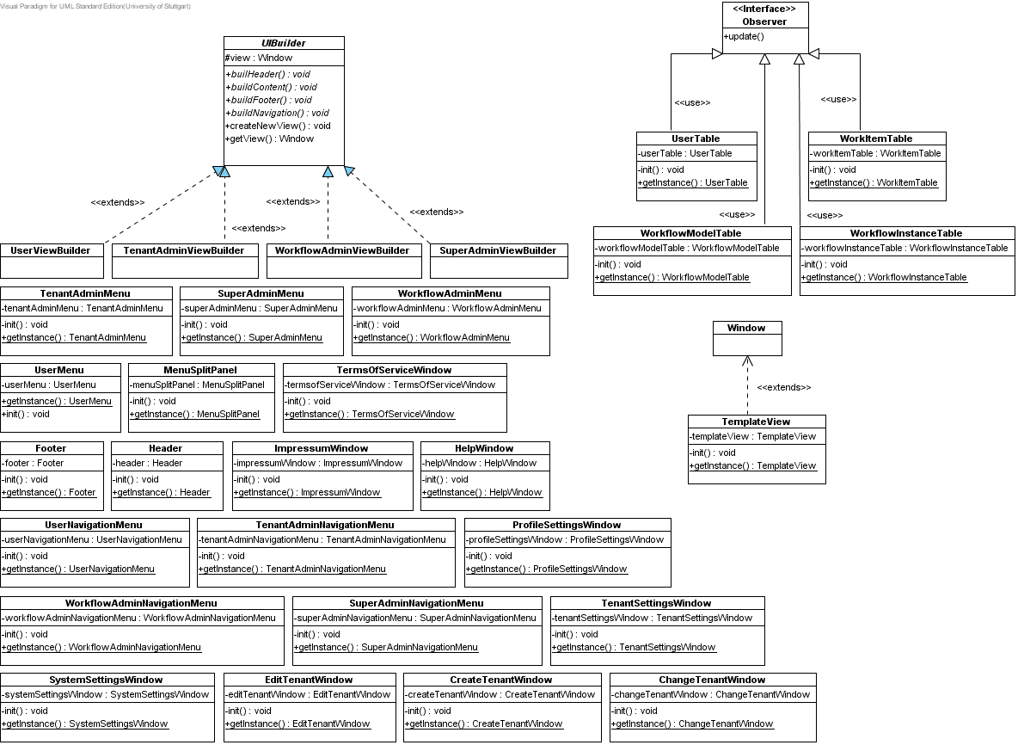

Design Patterns

Builder Pattern

UIBuilder
The builder pattern abstracts the steps of the view’s construction depending on the user’s role. There is an interface describing methods for creating components. In our case these components are the header, the content, the navigation bar and the footer. Also it is possible to create a new view. This new view is a window component which is provided by the ITMILL framework. In this window we can add our header, footer, content and navigation bar. To get the current window, where the components are shown we have the method getView().
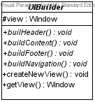

Concrete Builder
The concrete builder extends the UI builder. Every class builds its own conrete header, concrete content, concrete footer and concrete navigation bar depending on what role the user has. For every user there must be one class which extends the UI builder interface.
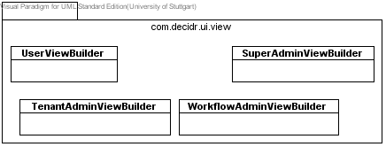

Director
The director manages the correct sequence for the view creation. It receives a concrete builder and executes the appropriate methods. The setUIBuilder(UIBuilder uiBuilder) method sets one of the concrete UI builder described in Concrete Builder. So the corresponding UI builder is set and can build the view which is appropriate to the user. With getBuilder() it is possible to receive the current UI builder. The constructView() method allows the user to call the specific methods from the UI builder like buildHeader(), buildContent(), buildFooter() and buildNavigation() to construct the view he wants.

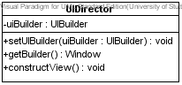
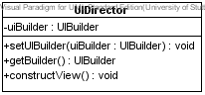

Communication
These entire separate components act together and finally a constructed view depending on the user’s role is the result. The UI director sets the concrete builder. So it is determined what kind of view will be built. After that the concrete builder starts to build the header, footer, content and navigation bar. The UI director calls the build methods from the UI builder and constructs the view depending on the UI builder which was set before. In the following picture the communication is shown.

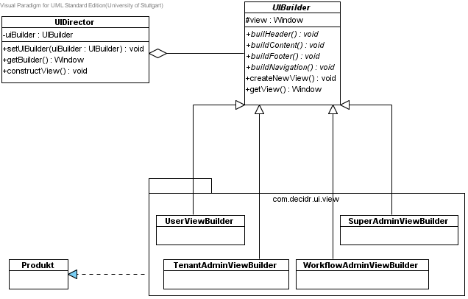

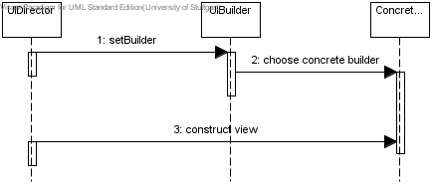

Observer Pattern
The observer pattern defines a one-to-many dependency between objects so that when one object changes state, all of its dependents are notified and updated automatically.
The observer pattern allows the view to change if the data has changed. The data which is changeable like users or workflow models extends the Observable class. The super class provides methods for adding, removing and notifying observer. If anything changes in these data classes the view will be notified about these changes and the update method from the Observer interface determines what to do. So that it works the view classes have to implement this interface.

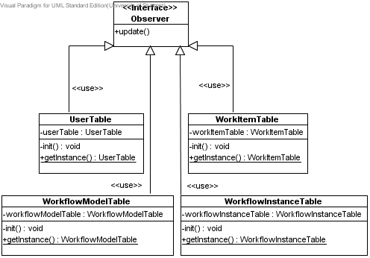

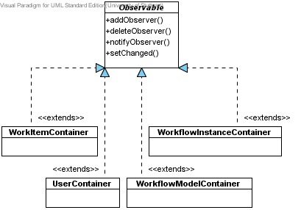

Action Registry
The registry isn’t a real pattern but it handles the action which will be used in the application. Every action is implemented in a separate class. This action class has to implement the Button.ClickListener interface. This interface provides the buttonClick(ClickEvent event) method. This method describes what the application shall do if the button is clicked. The action registry offers methods for adding, removing and getting such action classes. The action classes are registered in the action registry within a HashMap or another Collection. All action classes are maintained over the action registry. The action classes are located in the de.decidr.ui.controller package.
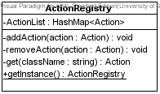

Singleton pattern
The singleton pattern ensures a class has only one instance, and provides a global point of access to it. Every view component implements the singleton pattern. The action registry implements the singleton pattern, too.

Data Binding
In the web portal there will be several tables, trees or anything else displaying information like workflow models, user list, workflow instances, work items and so on. To show these items on the web portal we decided to use containers in which we can store such information (properties). These properties are stored in Java Beans. These containers are connected with the corresponding components (table, trees, select). So the data is available through the containers where items can be extracted and placed in the view component to show the necessary information to the user. So the containers act as a controller in the web portal and delegate the information to the appropriate view components. ITMILL framework offers such containers, which can be filled with items. We will use the com.itmill.toolkit.data.Container interface and his methods for binding the data to the view components.
All these container classes extend the Observable class. By extending this class the containers are able to notify the corresponding view components if any data within the container has changed. For more information refer to Observer Pattern.

Navigation
The navigation in our “DecidR” application will not be a common page flow approach as it is usual for JSF or JSP applications. With the used ITMILL framework the navigation is handled like a normal desktop application. That means that there will be a swing-like approach. The flow is managed by action classes which are registered in the Action Registry.
The user can navigate through our application via a navigation bar displayed on the left side of the “DecidR” web portal.

Portal view structure
As mentioned in Builder Pattern the view is constructed depending on the user’s role. Every role has a specific view. In our case we have four roles: user, tenant admin, workflow admin and super admin. Starting from the user every following role has more privileges and therefore more components which are visible for the user with the concerning role. Exactly information on how the view is constructed have a look at Builder Pattern.

Authentication and start page
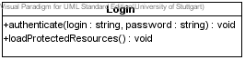

The user has to authenticate to the application to be able to perform any actions within the “DecidR” application. From a login window the user is able to enter his data (login and password). If the user submits, the method authenticate() from the login class is called. The login class is stored in de.decidr.ui.controller. This method takes the login and the password and sends them to the database via the user facade from the main model. There the login and password will be compared to the data which are stored on the database. If the comparison is successful the database sends a user object back to the web portal. Here the received user object is set via the com.itmill.toolkit.Application.setUser(Object user) method, so that the user is reachable application-wide .This variable can be used later for checking if a user is authenticated to the application. The user’s id will be stored into the session, too. For more information see Session Management.

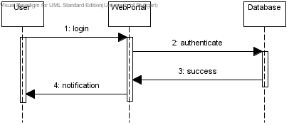

Also the authenticate method calls the loadProtectedResources() method. This method contains the UI components which are protected for unregistered users. Depending on the user’s role which is contained in the received user object from the database the specific UI builder is set in the loadProtectedResouces() method. For more information see Director.

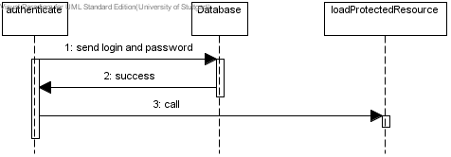

Also the loadProtectedResources() method prevents a unregistered user to navigate through our application because the method is called only if the user is successfully authenticated to the application. If the authentication fails the method isn’t called and no UI builder is set, so that no view is built. The user remains on the start page where he has some lower functionality. Also, the loadProtectedResources() method prevents a unregistered user to append names to the application URL to invoke specific web pages within the application. He will be redirected to the start page.
To prevent a registered user to append names to the URL to gain direct access to pages we add a security constraint to the web.xml of our web portal project:

<security-constraint>
<display-name>Default Security Constraints</display-name>
<web-resource-collection>
<web-resource-name>Restricted Directory</web-resource-name>
<url-pattern>/myapp/*</url-pattern>
<http-method>GET</http-method>
<http-method>POST</http-method>
</web-resource-collection>
<auth-constraint>
<role-name>Admin</role-name>
</auth-constraint>
<user-data-constraint>
<transport-guarantee>NONE</transport-guarantee>
</user-data-constraint>
</security-constraint>

Session Management
As mentioned in the section Authentication and start page the user has to authenticate. To avoid frequently connections to the database some information has to be stored in the session. So this information is accessible application-wide because every session has its own application instance and can be reached immediately without connecting to the database. The session will be reached over the com.itmill.toolkit.service.ApplicationContext and com.itmill.toolkit.terminal.gwt.server.WebApplicationContext which is provided from the ITMILL framework. The session is provided by javax.servlet.http:
ApplicationContext ctx = getContext();
WebApplicationContext webCtx = (WebApplicationContext) ctx;
HttpSession session = webCtx.getHttpSession();

The session will be generated within the authenticate method of the Login class. So only if a user is authenticated the information will be stored in the session.
Information like the user id, the current tenant and the portal role are stored in the session via the session.setAttribute(String arg0, Object arg1) method. The user’s id is used for verification. The current tenant is used for allocating the current tenant to the authenticated user. With the portal role the corresponding view is chosen, so that the user gets the right information displayed.

Secure connections
The application can use SSL for secure connections. There are no problems with the framework. The configuration has to be made on the tomcat server. There exists a configuration file named server.xml. This file is in the conf folder from the tomcat directory. First you have to create a certificate keystore.
If your tomcat runs on windows then execute the following command:
%JAVA_HOME%\bin\keytool –genkey –alias tomcat –keyalg RSA
If your tomcat runs on a unix system execute the following command:
$JAVA_HOME/bin/keytool –genkey –alias tomcat –keyalg RSA
And follow the instructions on the screen. You have to type in a password for the keystore.
In the next step you have to uncomment the “SSL HTTP/1.1 Connector” entry in $CATALINA_HOME/conf/server.xml and tweak as necessary.
The $CATALINA_HOME represents the home directory of your tomcat server.

Multiple windows
A user could open multiple tabs or windows and connect to the application. To prevent that the user authenticates twice on the same system and web browser the user will see the same page in every tab and window. To provide this functionality we have to override the getWindow() method from com.itmill.toolkit.ui.Window to make it the single window instance in the application.

@Override
public Window getWindow(String name) {
Window w = super.getWindow(name);
if (null == w) {
w = new MyWindow();
w.setName(name);
addWindow(w);
}
return w;
}

Different tenant view
Every tenant has his own logo and custom style sheet of the page. If a user switches to another tenant the logo and the CSS of the page will change. The logo will be set in the header. The corresponding CSS file will be fetched from the database.

